Historic Maryhill Inn up for sale

Current owners of inn that goes back some 170 years are retiring after 12 years
NEWS May 04, 2018 by James Jackson Waterloo Region Record
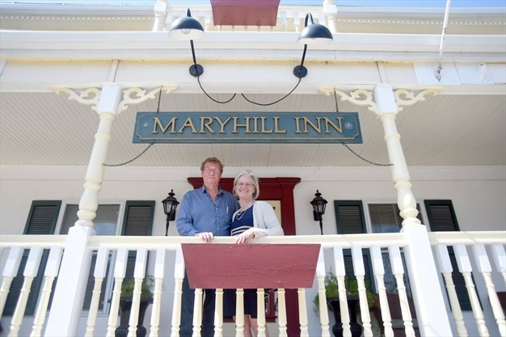
Maryhill Inn owners Webb and Sandra Kamminga stand on the front porch of the bed and breakfast operation. The couple is retiring and has put the property up for sale. - David Bebee,Waterloo Region Record

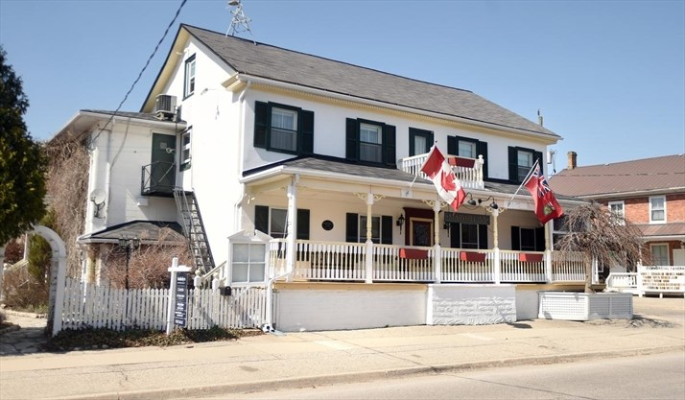
The historic Maryhill Inn has been put for sale for $1.3 million. - David Bebee , Waterloo Region Record

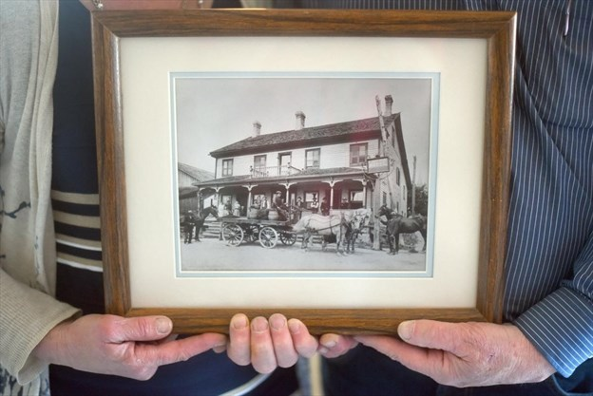
Sandra and Webb Kamminga hold a early photo of the Maryhill Inn taken in the early 1890s. - David Bebee , Waterloo Region Record
1 / 3
MARYHILL — A piece of local history is up for sale as the current owners of the Maryhill Inn are ready for retirement.
The inn, built circa 1850 and formerly known as the St. Boniface Hotel, was originally a five-year business plan for Webb and Sandra Kamminga when they purchased it in August 2006.
"Now that we're in our 11th year, we've decided it's time for a new chapter," said Webb, 64.
The couple had zero experience running an inn when they bought the property. Webb was a maintenance supervisor for Linamar in Guelph, and Sandra was a nurse for more than 30 years in Guelph. They had never even stayed at a bed-and-breakfast.
"It was a big learning curve that first year," said Webb. "But Sandra thought she wanted to tackle it, and it's been good to us."
They double-booked a room once, "but it has never happened again," added Sandra with a laugh. The couple run the entire inn themselves, including cooking a gourmet breakfast for customers, and they live there during much of the year as well.
The inn has stood the test of time, and part of that can be attributed to the way it was built. It was constructed using the post-and-beam method that was popular in Europe at the time, and the hand-hewn posts and beams are held together by wooden pegs rather than nails. The walls are filled with cement and river rocks.
The building style is on full display in the unfinished attic, wherebark is still visible on many of the posts, along with saw and axe marks.
The inn, which first operated as a stagecoach stop on the road between Guelph and Waterloo for 70 years, could be yours for $1.3 million. The couple thought they had the 4,600-square-foot building sold in late February, but the potential buyer disappeared just before the deal closed.
The inn includes six themed suites, from the luxurious Plantation Suite that is popular for honeymooners, to the more rustic Cottage Room that includes the original hardwood flooring and an old fashioned soaker tub.

The Kammingas have also worked to modernize the inn. When they bought it there was no internet and only three television channels thanks to an old rooftop aerial.
"Whenever someone with a CB radio drove by it would interfere with the transmission," said Sandra.
Now, they offer wireless internet and more than 300 channels. The inn is open all week but the majority of its clients come for the weekend, including for girls' weekends, weddings and conferences. Local MPPs have used the dining room to meet and greet constituents.
The inn has also served the Kamminga's well during holidays, when their three kids, four grandchildren, and nieces and nephews all visit and stay at the inn.
Standing prominently at the main intersection of town for more than 150 years, the inn has a rich history, and Webb is more than happy to share some of the tales passed down to the couple over the years.
Such as that one from around 1910 when a local priest noticed church attendance among men was dropping. So one day he walked down to the inn — at the time a popular bar for men only — and rounded up the men with a rifle in hand then marched them up the hill to St. Boniface Church.
"I'm 95 per cent sure that story is true," said Webb.
And while they don't believe in ghosts themselves, the couple has heard many stories of spooky occurrences from guests.
"We've had a number of guests claim 'you have ghosts' and maybe because we don't believe in ghosts we haven't seen them," said Webb.
"There were two women who said books flew out of the bookshelf and that there was no way they just fell off," added Sandra.
They've brought in paranormal investigators but they didn't turn up any ghostly activity.
"Someone died in one of the rooms. They fell off the steeple of the church and they brought them here and they died, so once and a while the TV will turn on by itself," said Webb. "But it could just be an electrical glitch or something."
jjackson@therecord.com

by James Jackson
James Jackson covers Waterloo city hall and is an awarding-winning news and feature writer for the Waterloo Chronicle. He can be reached atjjackson@waterloochronicle.ca . Follow him on Twitterand the Chronicle on Facebook
Email: jjackson@waterloochronicle.ca Facebook Twitter

