Social historian Joanna Rickert-Hall celebrates the stories of everyday people

‘Waterloo You Never Knew: Life on the Margins’ brings neglected histories back to life
WHATSON Oct 17, 2019 by Terry Pender Waterloo Region Record
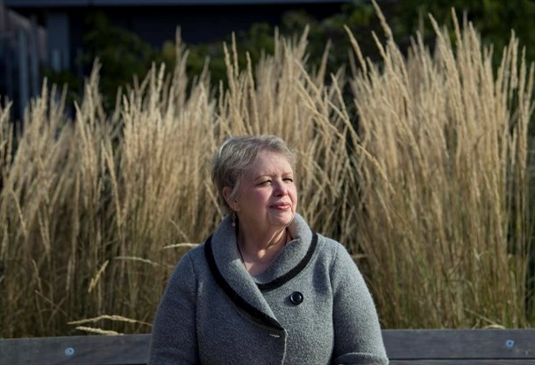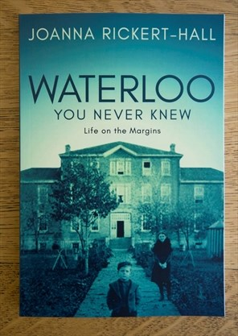
Joanna Rickert-Hall, author of “Waterloo You Never Knew: Life on the Margins.” - Mathew McCarthy , Record staff

Kitchener, Ontario - 2019-10-11 Joanna Rickert-Hall has written a book: "Waterloo You Never Knew: Life on the Margins." Mathew McCarthy, Record staff - see story by Terry Pender. Waterloo Region Record- shot 7:00:32 PM-2013-12-31-Kitchener - Mathew McCarthy , Record staff
1 / 2
WATERLOO REGION — The circus came to town and outraged citizens chased a racist clown into the woods.
It was called The Rice Circus, and it toured all over North America from about 1830 to 1890, billing itself "The Greatest Show on Earth."
Back then Kitchener was known as Berlin, and many blacks who had escaped slavery in the U.S. had settled on farms in the Queen's Bush, which ran from the village of Wellesley to Lake Huron.
The circus was owned by Dan Rice, who dressed as a clown for the show and sometimes performed with a pig. Rice and his troupe were from the U.S., where millions of blacks remained in slavery.
In the audience was Robert Sutherland. The son of an African-Jamaican woman and a Scottish father, he was the first black man to practise law in Upper Canada, and in 1855 he moved to Berlin. Among other legal work, Sutherland helped former slaves in the Queen's Bush gain title to the lands they cleared and settled.
When the clown saw there was a black man in the audience, he subjected Sutherland to racist heckling. Sutherland did not have to defend himself. Many Mennonites opposed slavery and racism, and literally chased the American clown out of the tent and into the woods. The circus packed up the next day and never returned.
The Rice Circus was bought a few years later by one of its employees and showmen — P.T. Barnum. Barnum changed the name, but kept the slogan — "the Greatest Show on Earth."
Joanna Rickert-Hall recounts this story in her book "Waterloo You Never Knew: Life on the Margins," published this year by Dundurn.
In the U.S., Rice is revered as a groundbreaking entertainment entrepreneur. A 2002 biography of Rice called "The First Vaudevillian" dubbed him the most famous man you never heard of. In Rickert-Hall's book, the circus owner is defrocked and exposed as a racist who verbally attacked the only black man in the audience.
She relishes the story.
"They weren't having it, and they chased him, they thrashed that clown and took him right out of town," she said. "I think this is a nice story about how the community looked after its own."
A social historian and author with degrees in history, urban planning, anthropology, religion and culture, Rickert-Hall teaches in the continuing education department at Wilfrid Laurier University.
In the book, she writes about people marginalized by ethnicity, social class and poverty. She also writes about people marginalized by their activities, such as the faith healer, Christian Eby, and the renowned landscape painter Homer Watson, who used Ouija boards and mediums to contact his dead wife.
Watson held many seances in his home, now the Homer Watson House & Gallery, in Kitchener's Doon neighbourhood.
"Following Homer's death in 1936, his sister Phoebe continued to live in the house, and it is believed that her spirit haunts the Homer Watson House & Gallery today," writes Rickert-Hall in her book.
In Waterloo Park today is a log cabin that was the area's first school house. It was built in 1820, and was once located near the current site of Grand River Hospital on King Street West. When a bigger school was built, Levi Carroll moved in and lived there for nearly 50 years.
He escaped slavery in the U.S. through the Underground Railway and settled in Berlin. He outlived three wives. His grandson, William James Aylestock married Jemima Lawson.
The Lawsons were among the first black families to settle in the Queen's Bush. One of their eight children was Rella Braithwaite, who became an accomplished writer and researcher of black history. She helped the Ontario government develop a Black Studies Guide for Ontario schools.
Rella's daughter Diana Braithwaite is well known to blues fans in this area. She has performed many times at the Sunday Gospel Breakfast during the Kitchener Blues Festival.
She and her partner Chris Whitely have brought their show Stories From the Underground Railroad to this region more than once. For 10 years they performed in schools, where 150,000 students saw the musical.
"She is amazing and so kind," Rickert-Hall said of Braithwaite.
In addition to stories about escaped slaves, she writes about the cholera epidemic that hit Galt in 1834, children in orphanages, the poor house, bootleggers, a bodysnatching doctor and the occult.
Rickert-Hall has plans to publish two more books about local history. Before that, she delivers a presentation in early November at The Museum about photographing spirits during seances — ectoplasm photography.
It is part of The Museum's exhibition called Afterlife: The Seance Experience. The exhibition is about Thomas Lacey, who became known for communicating with the dead. Rickert-Hall writes about him in her book, too.
She hopes her book gets people thinking about people who live in the margins today. That's what attracts her to social history — the stories of everyday people.
"We go through our lives every day and we really don't see the world that is right in front of us," said Rickert-Hall. "How many people notice the person on the street?"
tpender@therecord.com
Twitter: @PenderRecord
tpender@therecord.comTwitter: @PenderRecord
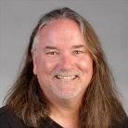

by Terry Pender
Terry Pender covers business and can be reached via Twitter @PenderRecord.
Email: tpender@therecord.com Facebook Twitter

