Otis and Larry’s
Lions Foundation of Canada
PetValu Walk for Dog Guides 2019
In association with the Ariss & Maryhill, Elora and Belwood Lions Clubs
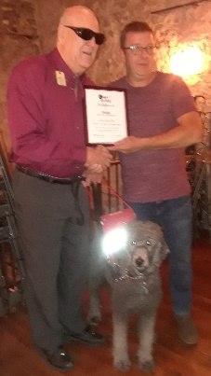
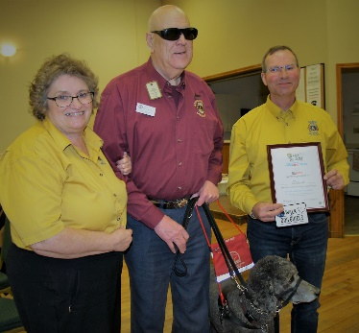
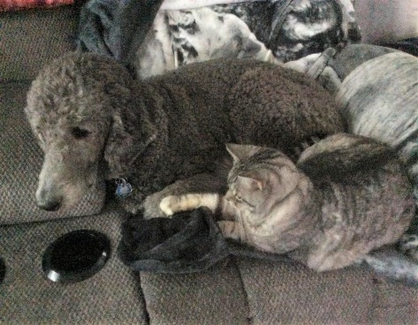
Wake up Otis
Time to train for the walk

Presentation to Belwood Lions Club for 2018 participation
Presentation to Elora Lions Club for 2018 participation
The Lions Foundation of Canada’s 3000th dog guide since 1985 will graduate this year. The Foundation is now training and graduating dogs in our 7th program, a Support Dog Guide. These special dogs are for use by professional agencies with individuals in traumatic situations, trained to provide comfort to victims or witnesses of a crime or sudden tragedy. Support Dog Guides will provide on scene support when requested to those most vulnerable in our community, as well as provide added support to persons providing difficult disclosure to police for crimes such as child abuse, sexual assault, etc. The first dog graduated is serving with the Halton Hills Police Dept. Dogs Guides are also trained for canine vision, hearing ear, service, seizure response, autism assistance and diabetic alert.
As Otis and I begin our 6th Walk to support the Lions Foundation of Canada Dog Guide Program continuing our journey toward our $25,000 goal (the cost to train and graduate a dog guide) we ask you to support us and donate to this excellent program making a tremendous difference in many peoples lives.
Every dollar from the walk each year goes strictly to the dog guide breeding, training, fostering, and graduating programs. A receipt from the Lions Foundation of Canada will be issued for a donation of $20.00 or more.
To donate click on the hyperlink https://www.walkfordogguides.com/locations/walker.cfm?ID=780&EventID=1778
Or personally sign my pledge sheet or mail your donation made out to the Lions Foundation of Canada, to Larry Wainwright, 508 Shortreed Ave., Fergus, ON N1M 3H5. (Unable to use above link under PetValu Walk for Dog Guides go to Ontario>Maryhill>walker Larry Wainwright to donate)
Realising every day how blessed I am to have received the gift of my vision dog guide Otis in my life.
Larry Wainwright 519 843 4516
Email: lionlrw@yahoo.com

